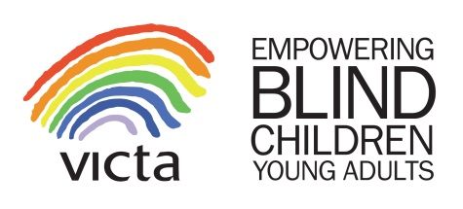
Sponsorship and Gift Aid
Declaration Form

Name: | Ref:
*PLEASE DO NOT ENTER WORK ADDRESSES AS WE THEN CANNOT CLAIM GIFTAID
Full Name | First Line of Home Address | Postcode | Amount | Date Pledged | Gift Aid  () | Paid  ()
(Example) Joan Smith | 32 Raven Road | MK1 1EK | £20.00 | 01/05/2018
TOTAL £
We, who have given our names and addresses above and ticked the box, headed ‘Gift aid’ want VICTA Children Ltd to reclaim tax on the donation as detailed below. We understand that we must have paid, or will pay an amount of income tax/capital gains tax, at least equal to the tax that the charity reclaims on our donation in the tax year.
Tax Reclaimed will be 25p per £1 donated

